**Meeting Minutes**

**Date:** March 8, 2014

**Start Time:** 10:00am

**End Time:** 1:00pm

**Members Present:** Drew Aaron, Michael Beaver, Clay Boren,

Chad Farley, Andrew Hamilton, and Travis Hunt

**Members Absent:** N/A

**Topics** **Discussed**

* Detailed Design
* Coding Standards

**Decisions and Actions Taken**

Michael and Chad worked on the Detailed Design. They mainly focused on defining the memory organization and representation. This was a critical step that will now allow for more rigorous development of the Backend Detailed Design. Essentially the main Memory contents are defined as an array of Bytes. In turn, Bytes are defined as two arrays of bits: High; and, Low. The Bit class is essentially an integer that can be either 0 or 1. Of course, all of these classes have accessor and mutator methods. It is also important to note that the team will need to overload the addition, subtraction, multiplication, division, etc. operators to manipulate the Bits and the Bytes.

In addition to the main Memory, there is a Register class that will be instantiated in an array of 17 objects within the Backend Simulator. Each Register is composed of an array of four Bytes. There are also accessor and mutator methods. We will also need to account for the Program Status Word (PSW), a special type of Register. Hence, a PSW class will inherit from the Register class. The PSW class will have an array of eight Bytes, which is double the normal amount. The PSW will also have a Condition Code. The Condition Code will be composed of an array of two Bits. Of course, the PSW and the Condition Code classes will have appropriate accessor and mutator methods. See the attached class hierarchies.

Travis, Andrew, Drew, and Clay worked on the coding standards. The coding standards are a mixture of already established Visual C# standards and other various standards found online. Andrew will finalize the coding standards and distribute them to the team.

The next team meeting will be Sunday, March 9, 2014 at 1:00pm in the Christian Student Center.

**Supplementary Information**

**Main Memory Class Hierarchy**

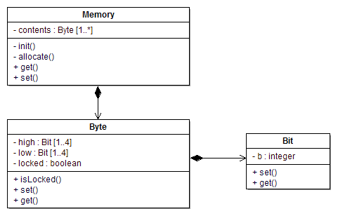

**Register Class Hierarchy**

